**BSCH-SD2**

**Weather Chat Bot Project**

**Umar Tariq - 3042331 | Gustavo Selemem - 3042264**

Table of Contents

**Introduction** 3

**Project Timeline** 4

**Project Structure** 5

**Team Collaboration Tool** 7

**Weather API** 8

**UI Implementation** 10

**Chatbot** 12

**Milestone 1** 13

**Milestone 2** 14

**Milestone 3** 16

**Commit Logs** 18

**Conclusion** 20

# **Introduction**

In this project we are creating an android application of a chatbot that uses an API to get the weather of a specific area and suggests appropriate clothing according to the weather. The chatbot asks for a city that the user is willing to visit and gives the weather forecast and appropriate clothing for the days requested.

The technologies being used are Android Studio and IntelliJ. IntelliJ was used in the first quarter of the development phase to construct the API class while the UI of the app was being developed on Android Studio. Both parts were merged to get a fully functional chatbot application.

The API being used is Meta Weather API.

The emulator being used is the standard Android Studio emulator and Nox player emulator.

# **Project Timeline**

The project is developed over an 8-week period divided into 3 milestones. Each milestone is after 2 weeks until final projected submission on the 8th week.

Testing is carried throughout the whole development phase.

|  |  |  |  |  |  |  |  |  |
| --- | --- | --- | --- | --- | --- | --- | --- | --- |
|  | Week 1 | Week 2 | Week 3 | Week 4 | Week 5 | Week 6 | Week 7 | Week 8 |
| Research |  |  |  |  |  |  |  |  |
| Connecting to the API |  |  |  |  |  |  |  |  |
| Retrieve and display data from the API |  |  |  |  |  |  |  |  |
| Extract required data from JSON response |  |  |  |  |  |  |  |  |
| UI Implementation |  |  |  |  |  |  |  |  |
| Connection between Activities |  |  |  |  |  |  |  |  |
| Connect Interface to backend |  |  |  |  |  |  |  |  |
| Coding bot responses |  |  |  |  |  |  |  |  |
| Testing |  |  |  |  |  |  |  |  |

**Milestone Dates:**

7th April 2022

26th April 2022

11th May 2022

# **Project Structure**

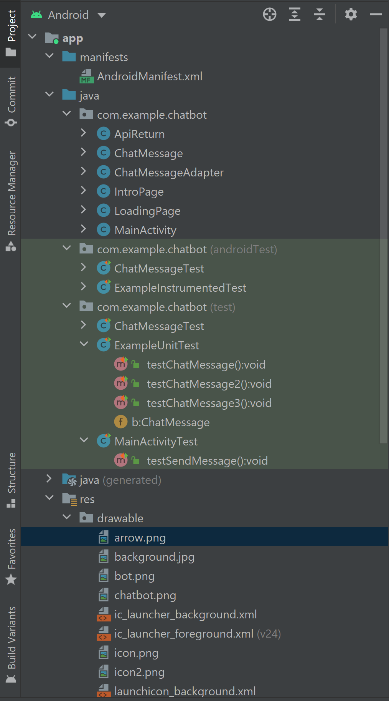

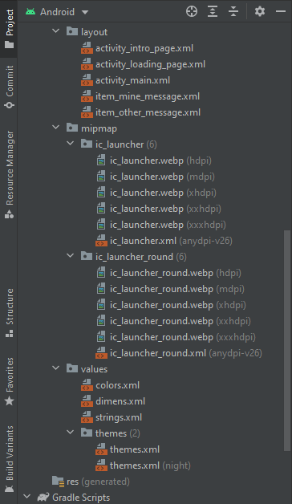

**Version Approach**

The project uses Griffith College Git Lab as its version control system. This makes it easy for everyone on the team to share code and keep log of each update to the project.

It also provides easy roll back in case of encountering issues.

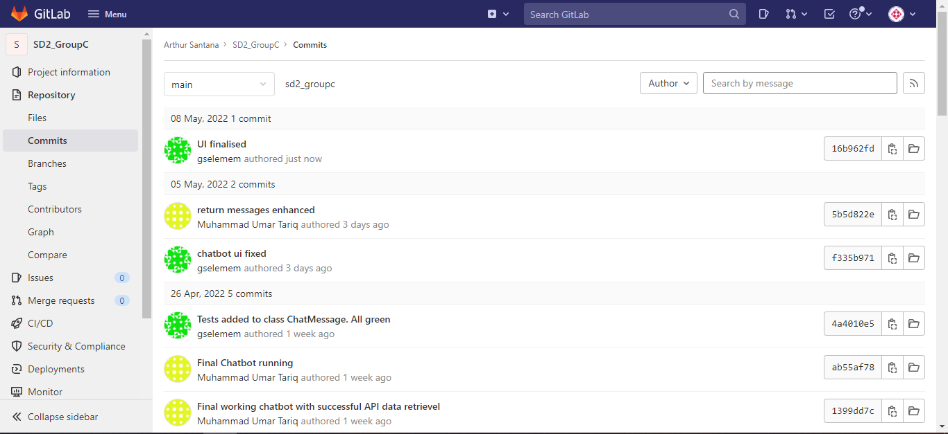

**Links:**

<https://gitlab.griffith.ie/>

<https://gitlab.griffith.ie/ArthurSan/sd2_groupc>

# **Team Collaboration Tool**

For team collaboration we are using an online tool called Trello. We are using this to set up goals, keep everyone updated on the progress, share screenshots of what we have done and share useful links.

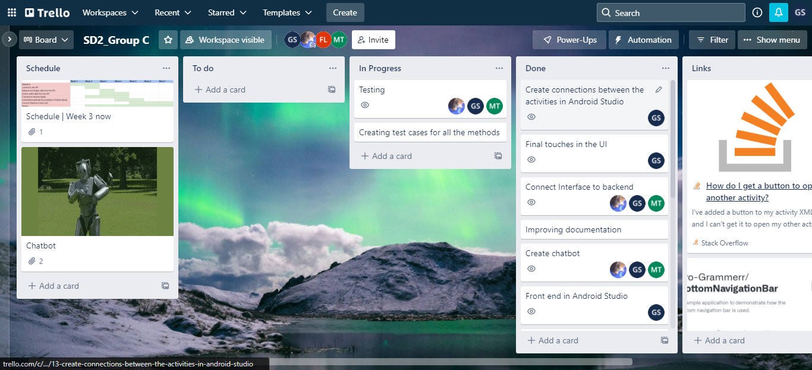

**Link:**

https://trello.com/b/WG2t6eK2/sd2group-c

# **Weather API**

The weather data is retrieved using the MetaWeather API. It returns a JSON Object with a JSON Array of Objects that have the weather forecast for next 5 days.

The class ApiReturn is created to connect to the API and retrieve data from it. The connection is made using Volley library. This uses a Request Queue to connect to the API and retrieve data, storing it in ArrayLists which are then used to display and process the data.

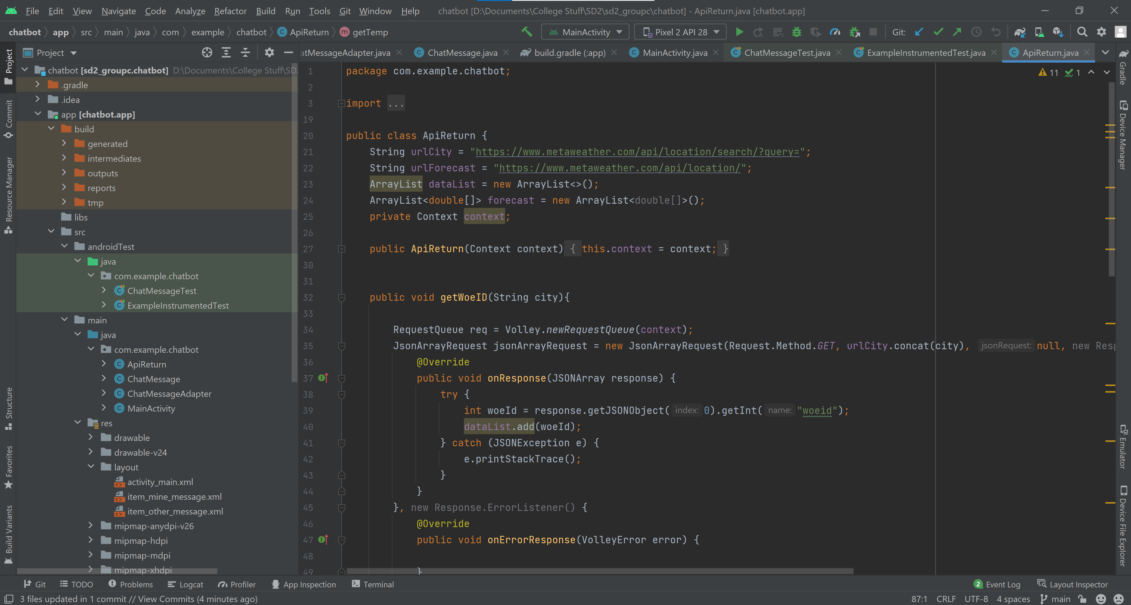

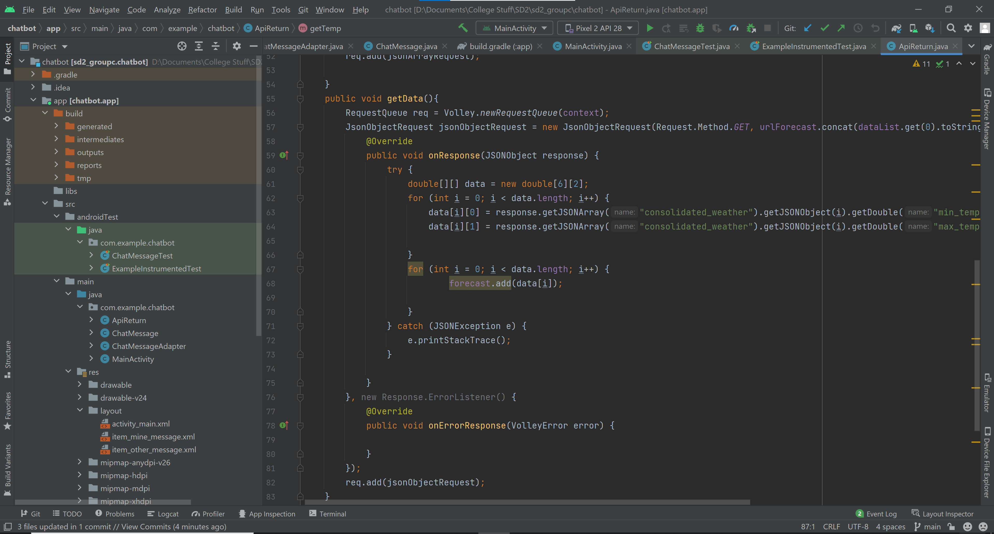

**URL passed:**

<https://www.metaweather.com/api/location/search/?query=><city name>

This link takes in the city name and returns information about the city



The woeid is extracted from this call.

<https://www.metaweather.com/api/location/><woeid>

It is fed into this link and then another call is made to retrieve the weather forecast

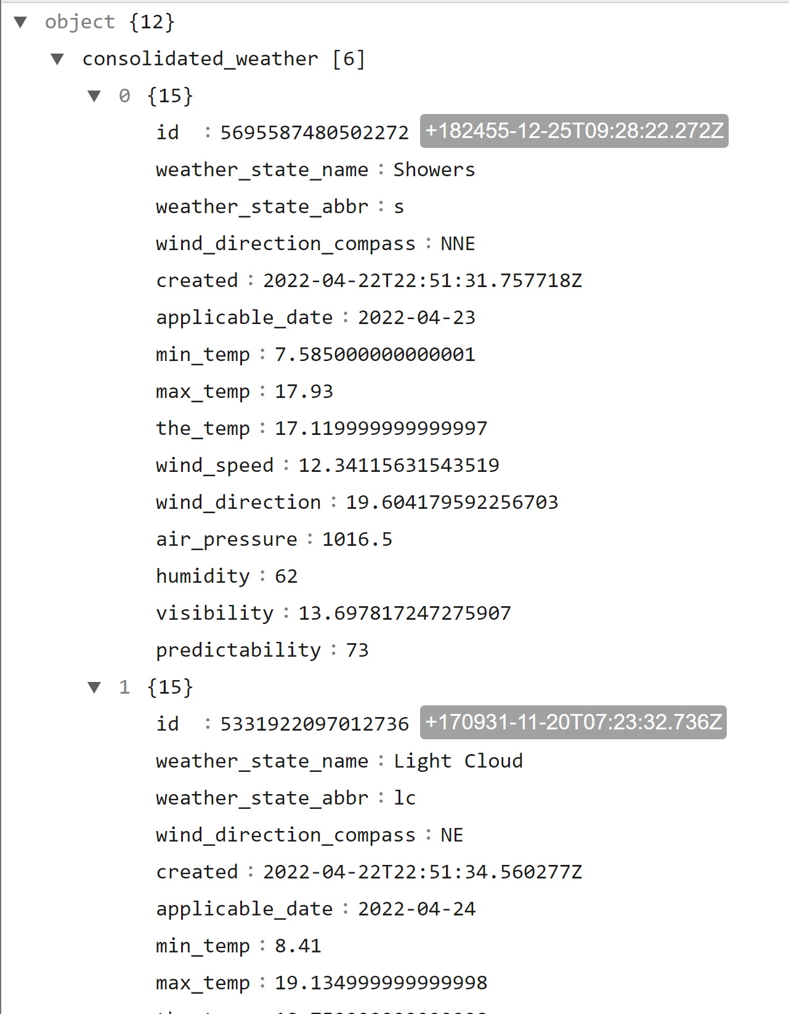

**Links:**

<https://www.metaweather.com/api/>

Cities supported by this app: <https://www.metaweather.com/map/>

# **UI Implementation**

The interface is being created using Android Studio. We have created three pages for the app: the first is a simple loading page to start the application. The second is the main page, where the user can start the application, and the third, and last page, is the chatbot itself.

The UI is being developed using XML files to which takes elements from Android Studio (buttons, text boxes, etc) and drawable objects (pictures, icons, etc) to compose the layout.

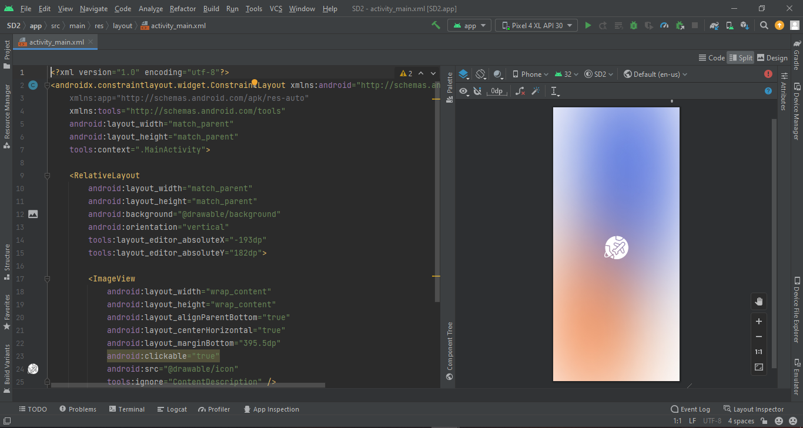

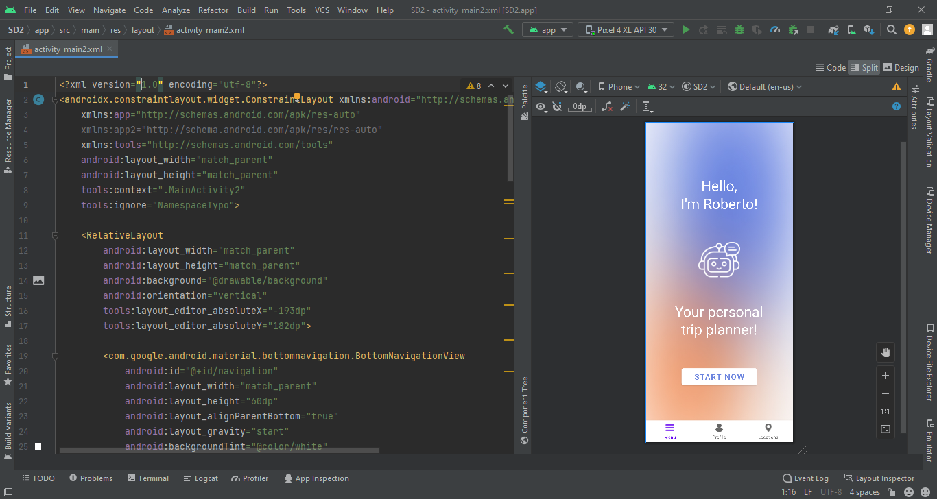

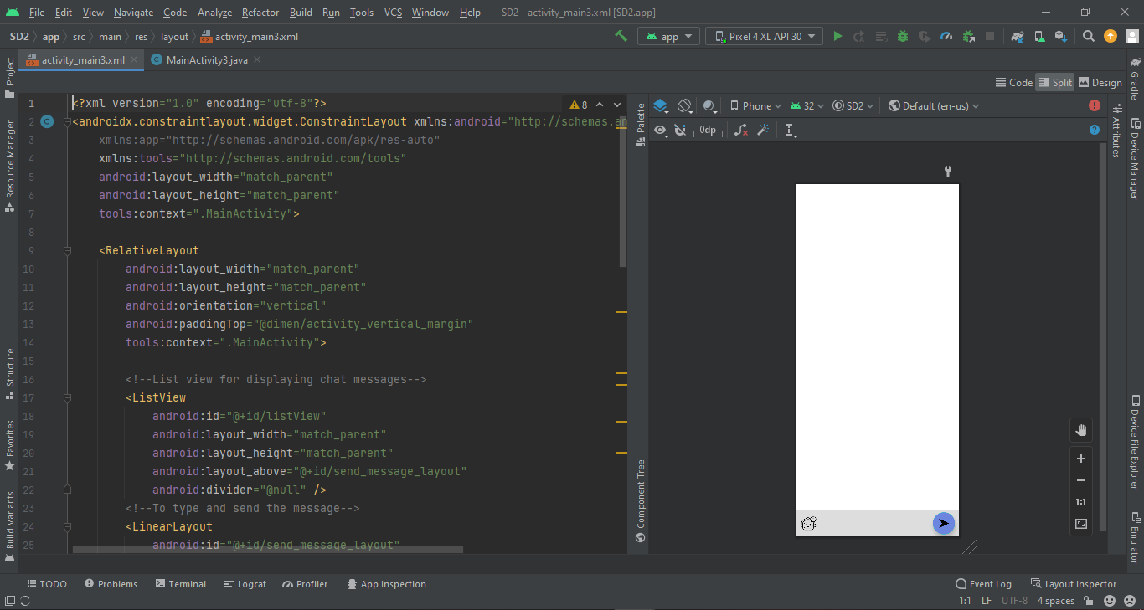

# **Chatbot**

The chatbot was developed in Java. It has a onClick method that is connected to the button in the interface, taking the user’s input to the sendMessage method, which compare the input into a collection of if and else if statements and answering with the correct reply.

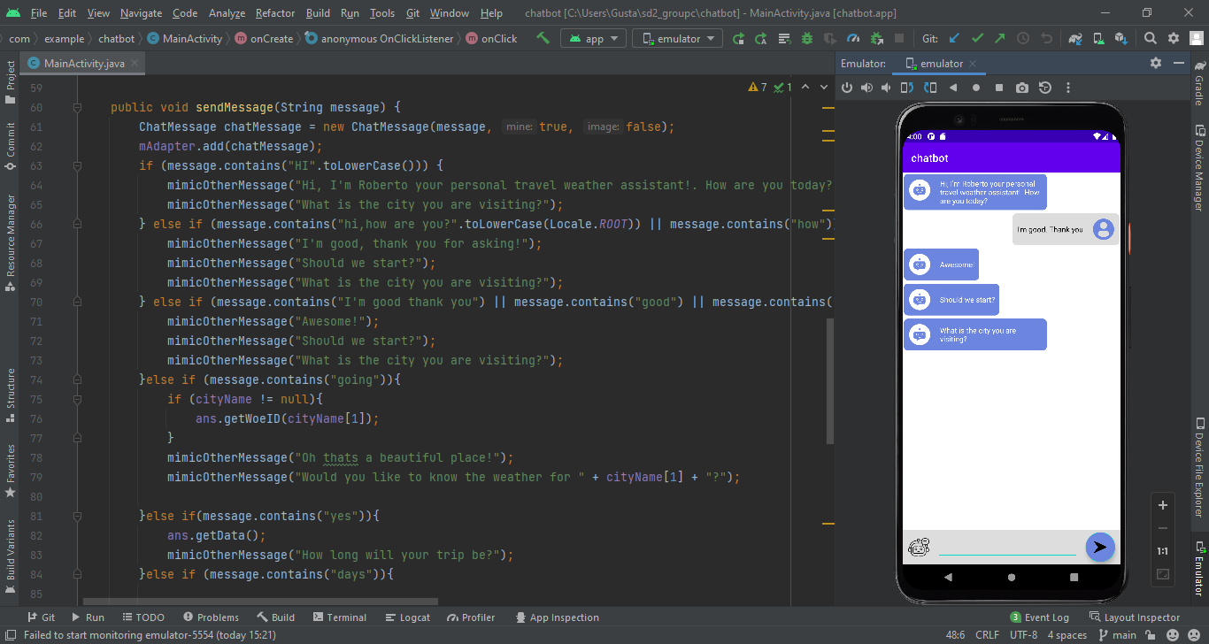

**Milestones**

## **Milestone 1**

The first milestone was creating a basic structure of the project and getting a working model of the UI and response from the API with hardcoded values.

**Achievements:**

* Setup Version Control System
* Create a collaboration platform
* Setup a working UI
* Connect and retrieve a response from the API

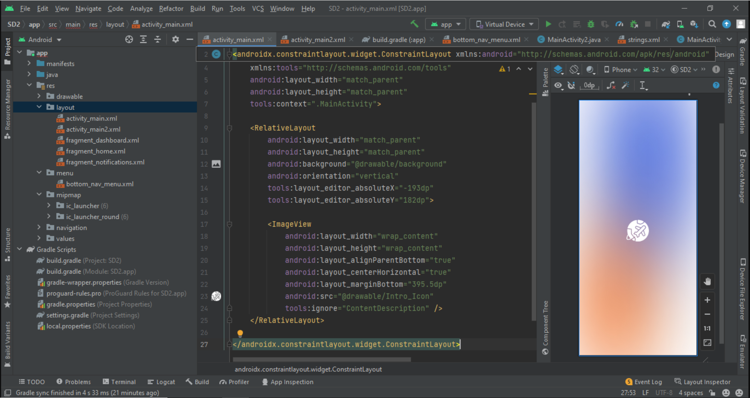

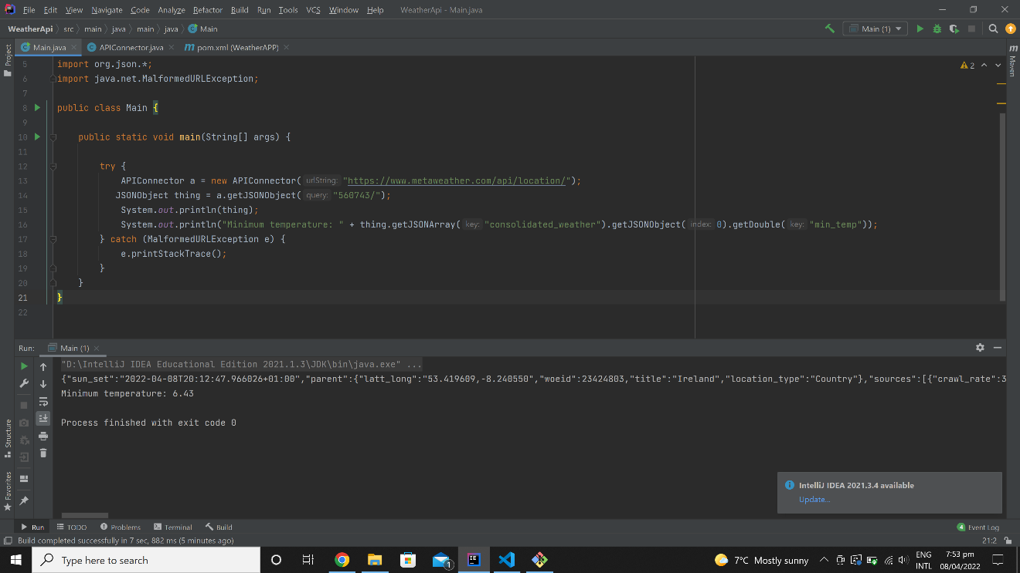

## **Milestone 2**

The second milestone required a basic working model of the chatbot with the backend and frontend merged together. The API response to be extracted for required information and a few test cases to be created.

**Achievements:**

* Working chatbot with hardcoded responses
* Backend and frontend merged with a working model of the app
* Useful data extracted and stored in ArrayLists from the JSON API response
* Test cases created.

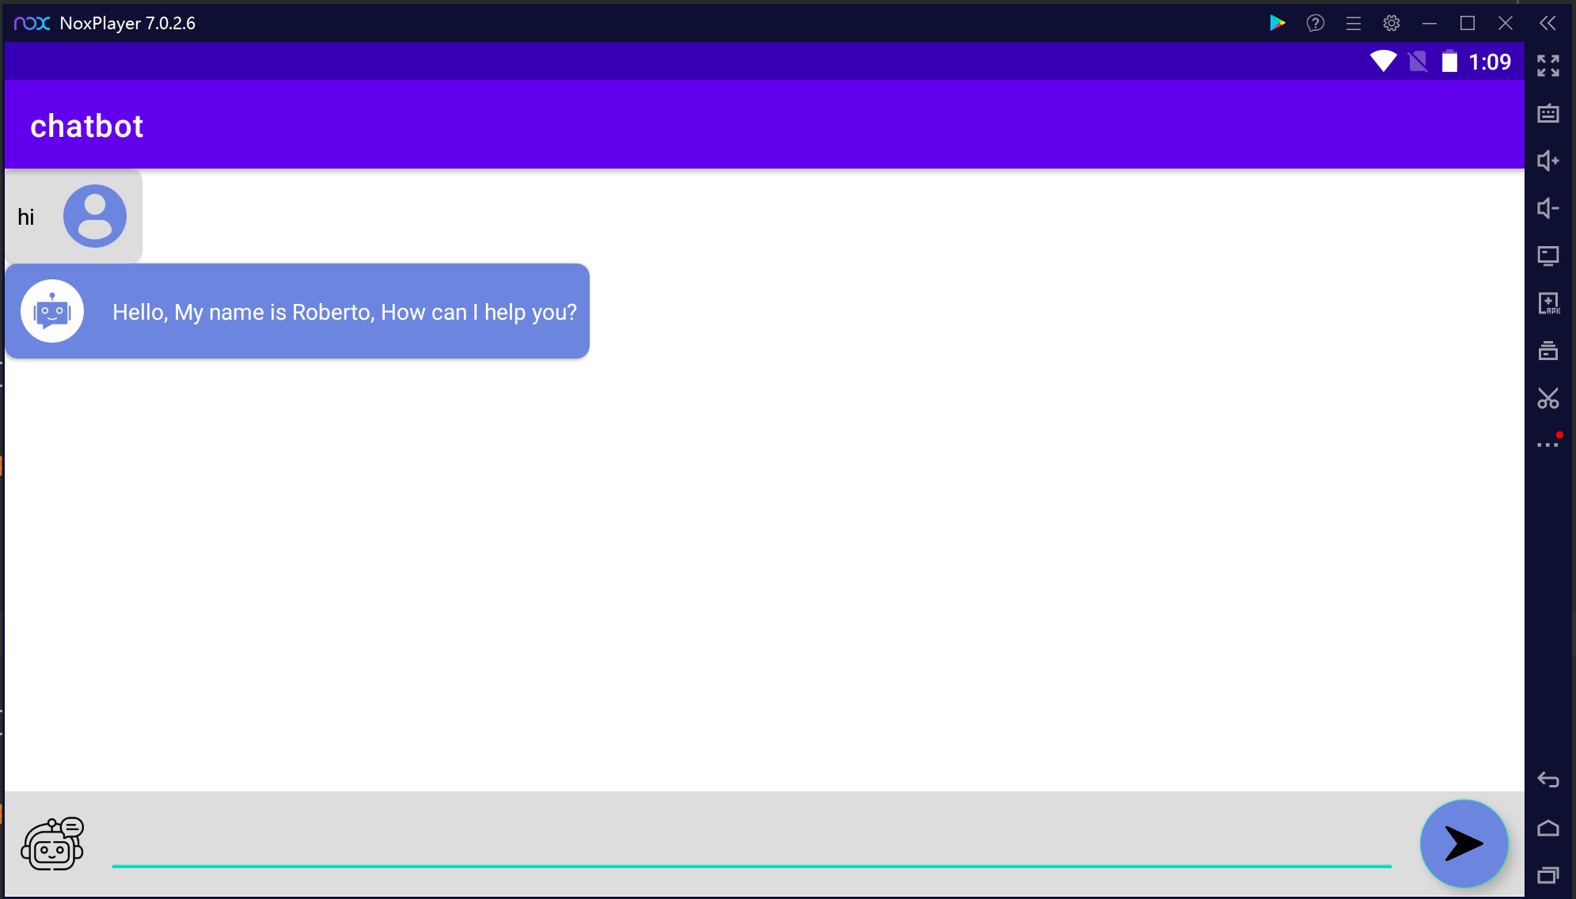

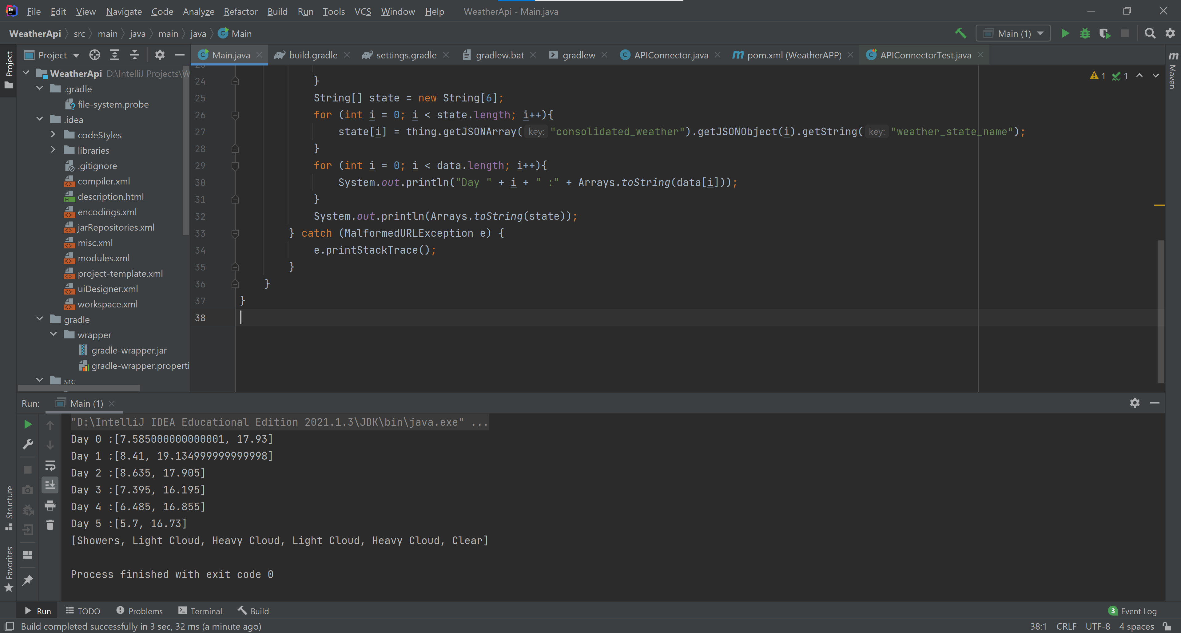

**Test cases:**

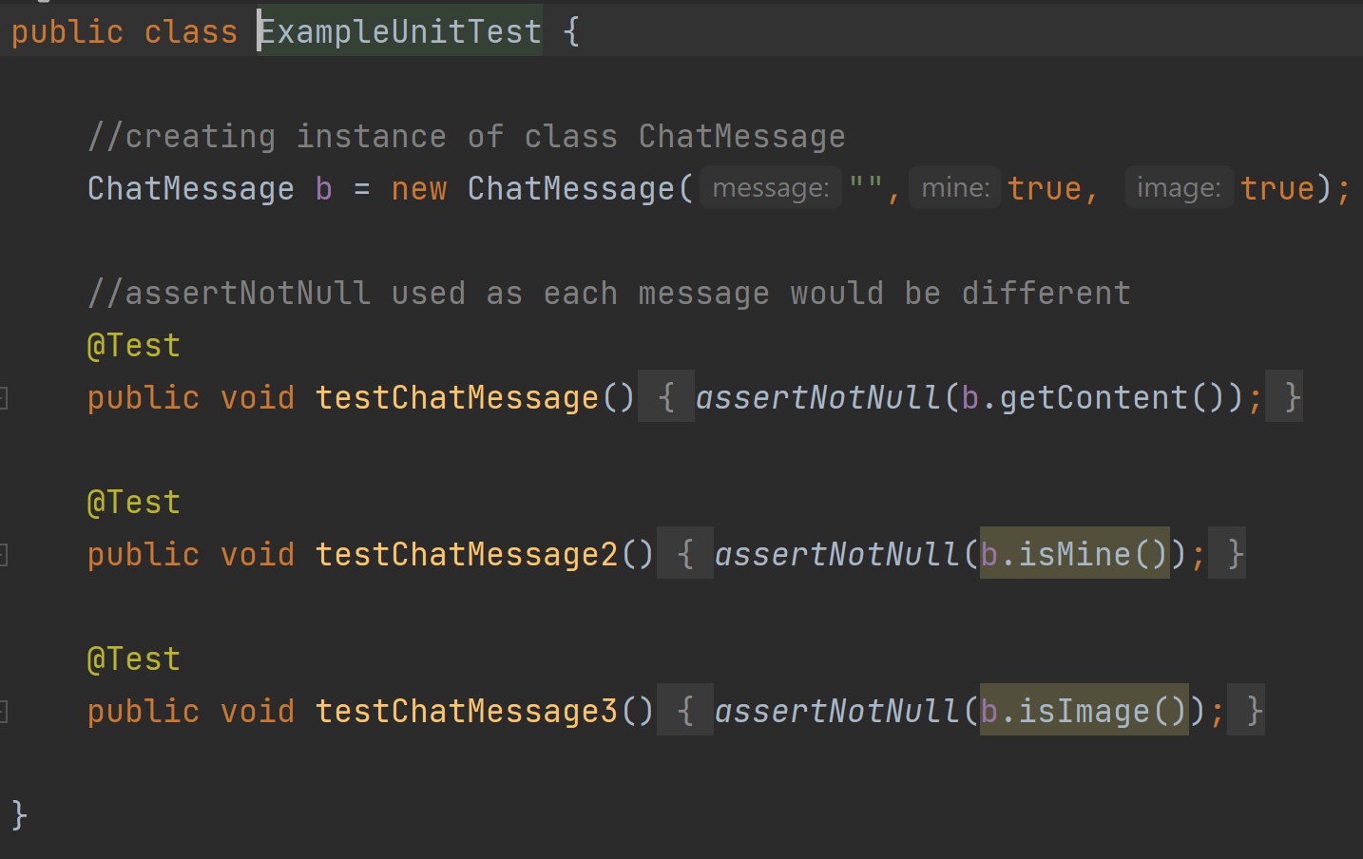

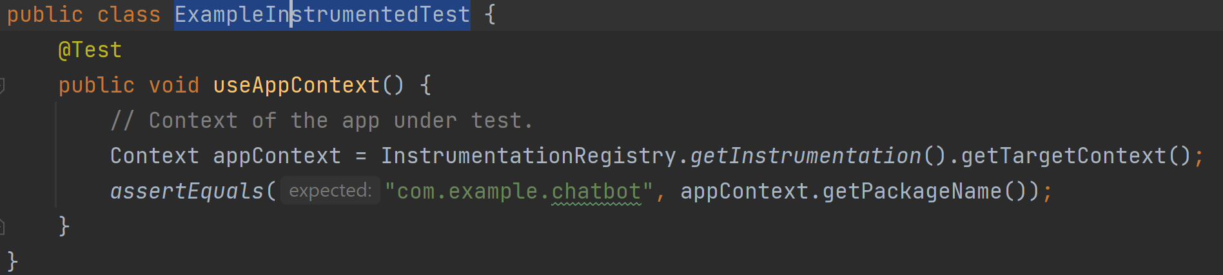

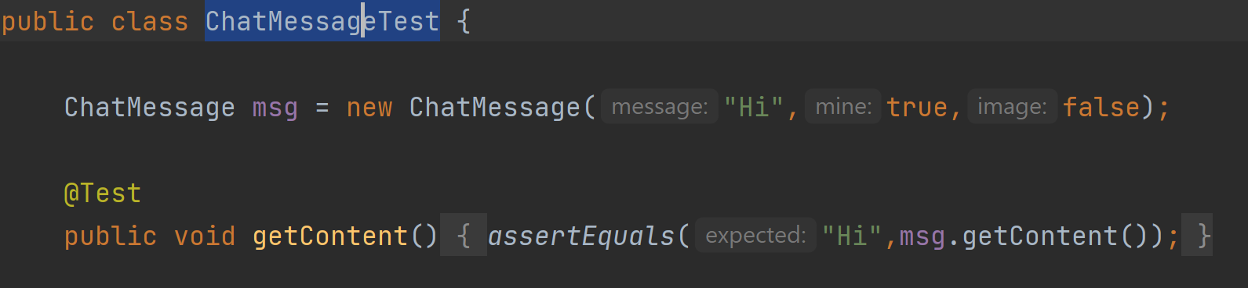

## **Milestone 3**

In the third milestone we have created the chatbot answers using if statements in the sendMessage method. The bot leads the user to answer what it needs to complete its task, which is to inform the user how the weather will be in the number of days asked and recommend clothes accordingly.

We also connected all the activities in the UI making the project a full app instead of just a chat box.

We have also created apk files to run the app on our phones.

**Achievements:**

* Fixed flow of the dialogue boxes
* Added the clothing suggestions
* Made the reply a proper message
* Fixed giving response for the number of days entered
* Added a loading page and intro page

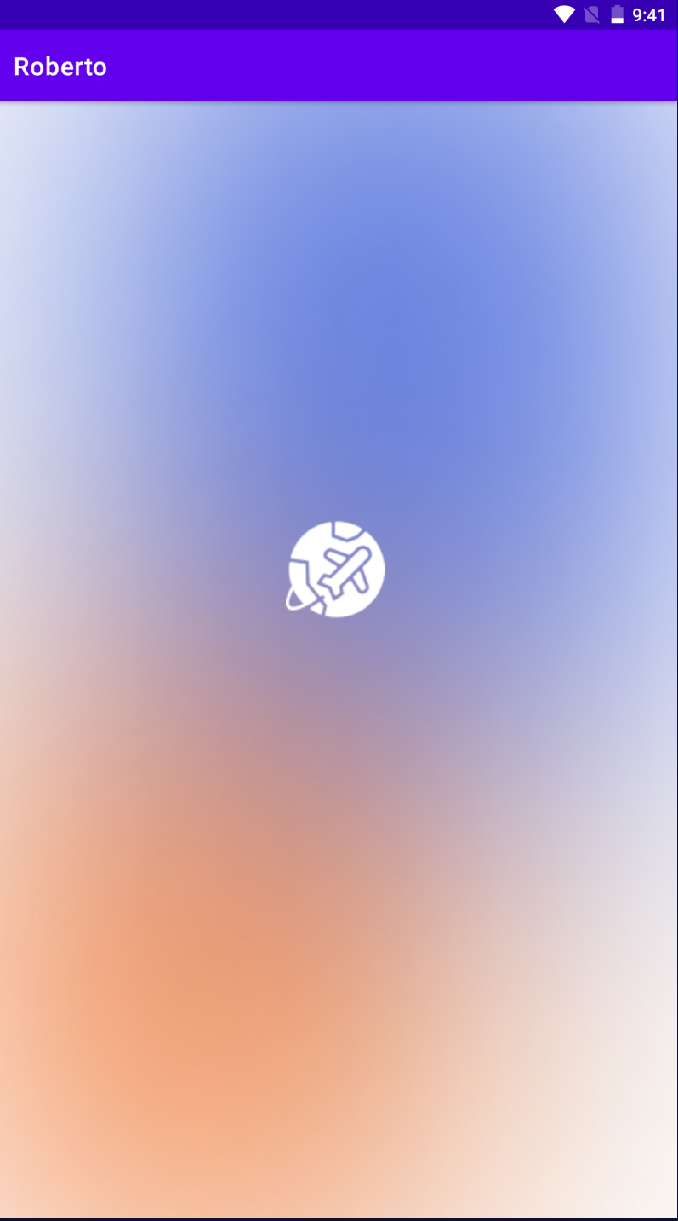 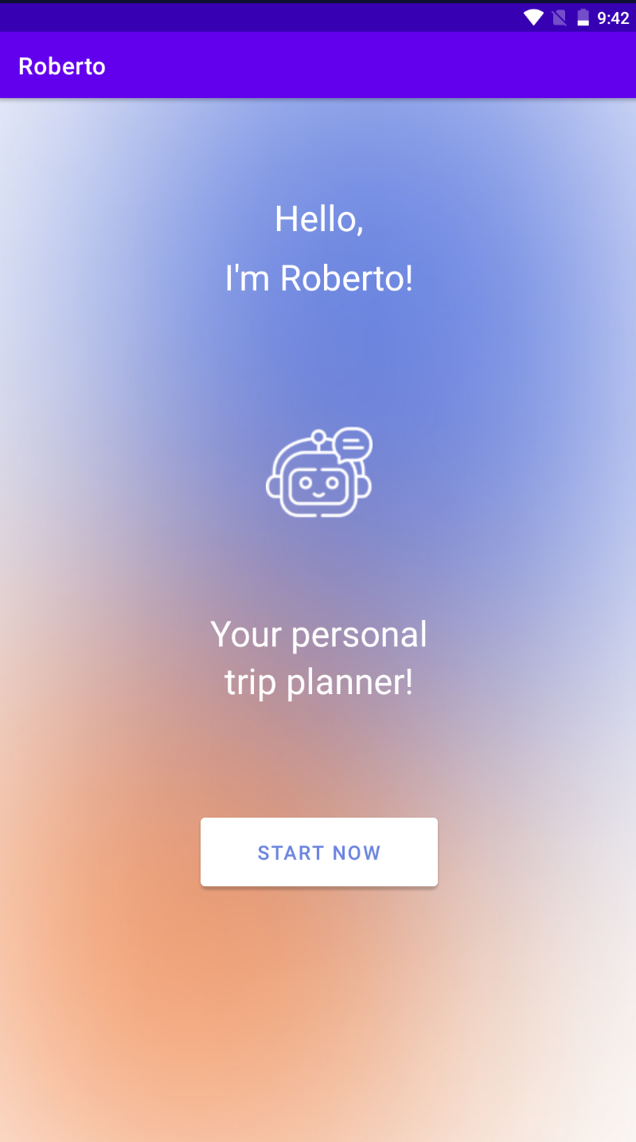

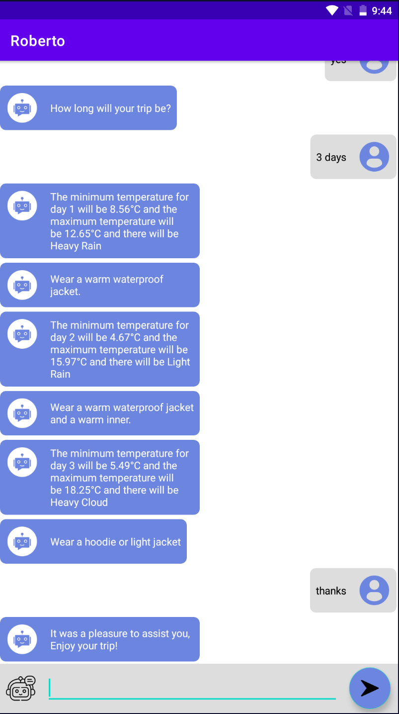

**Test cases:**

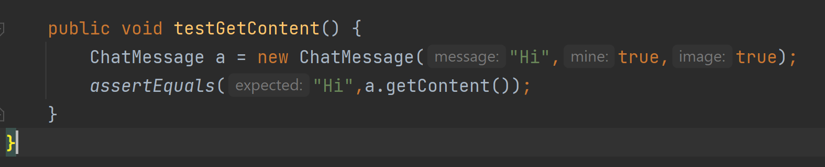

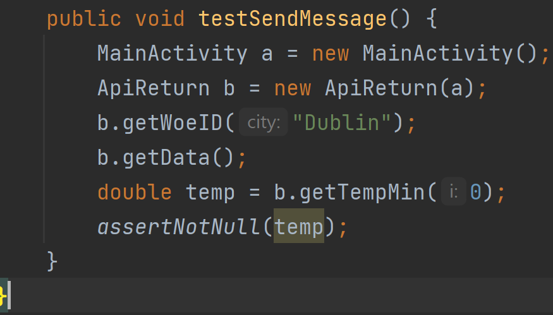

# **Commit Logs**

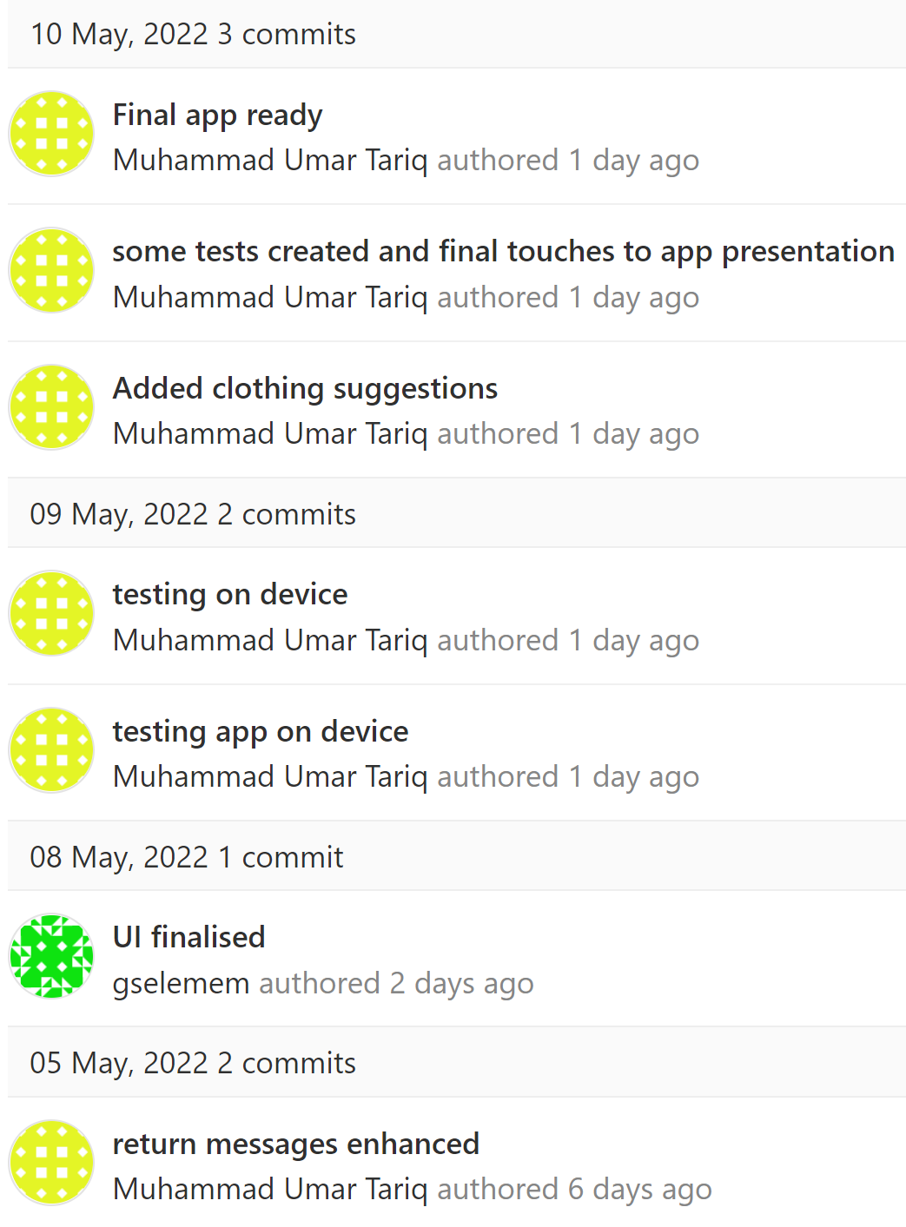

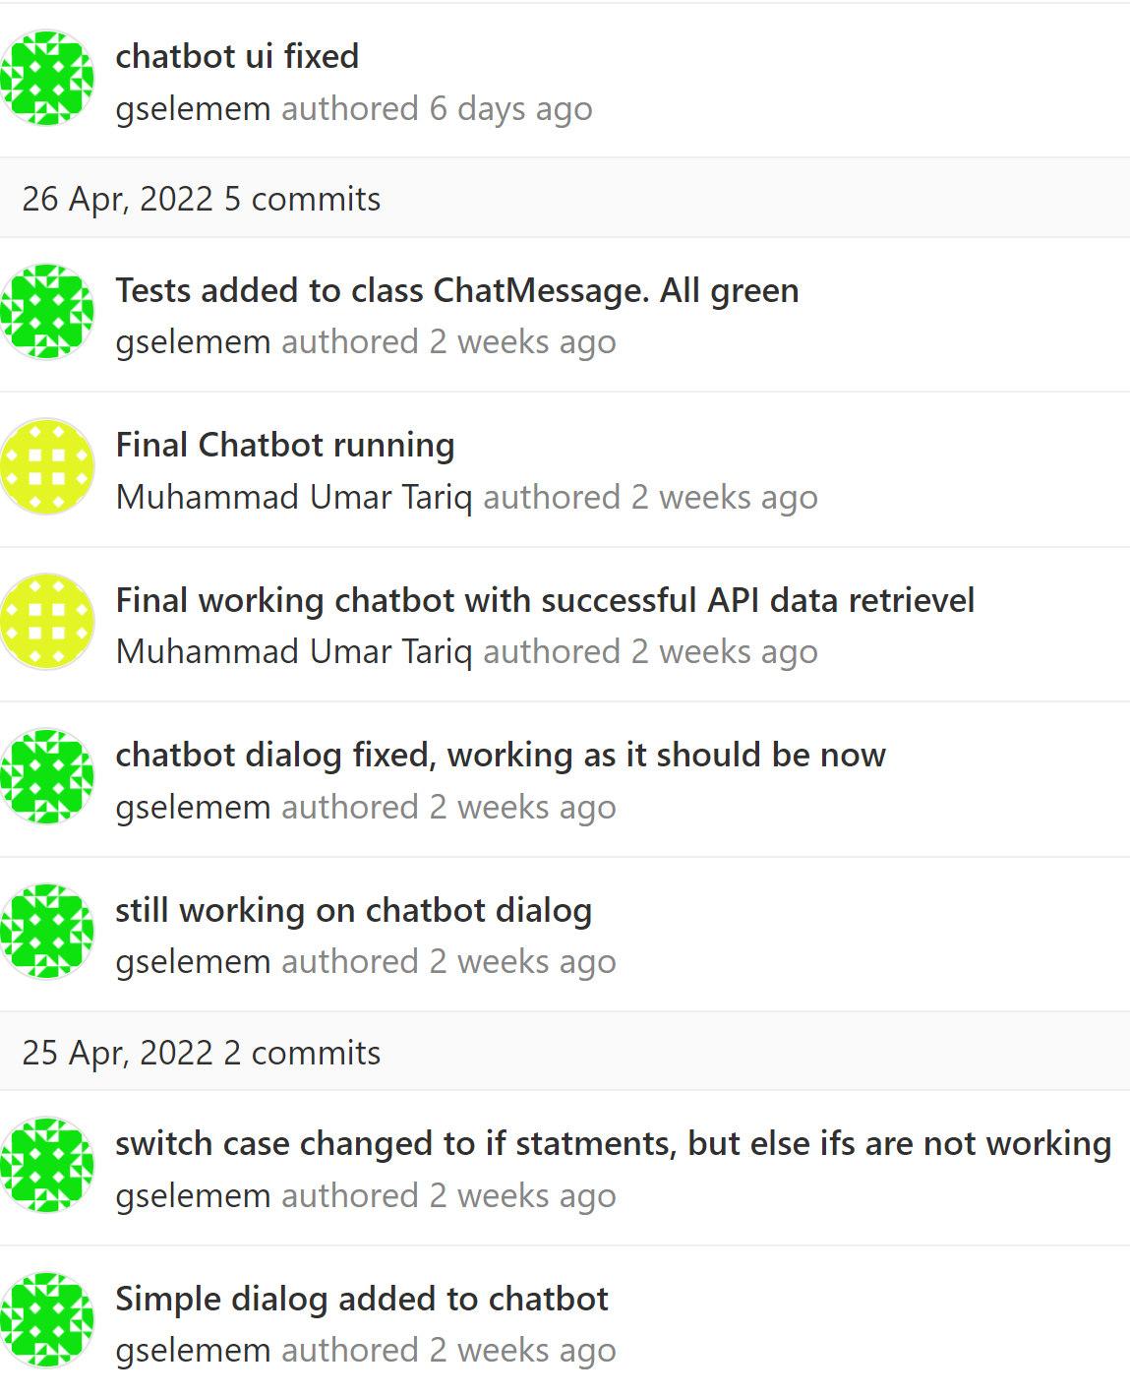

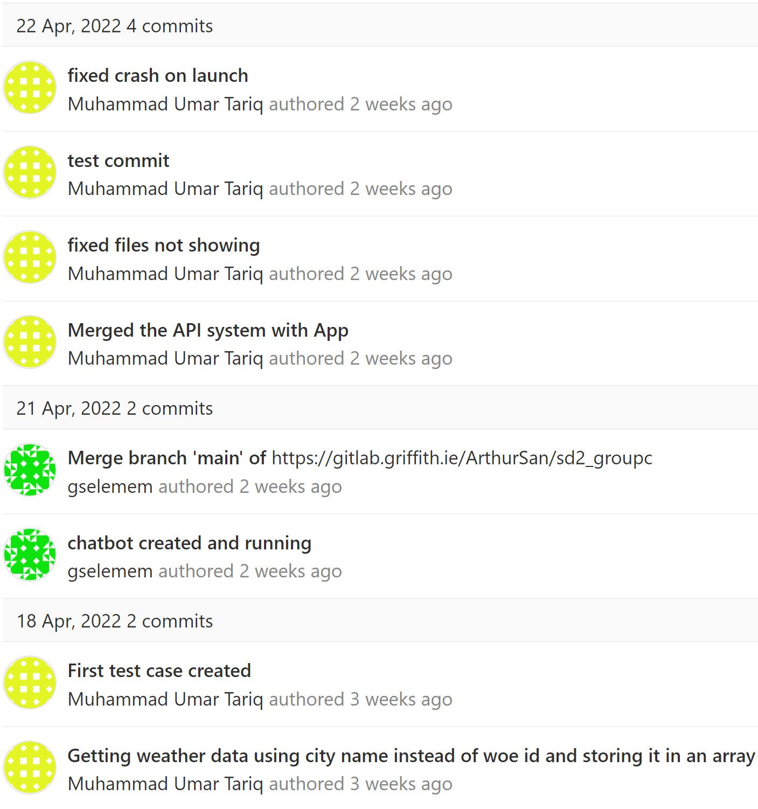

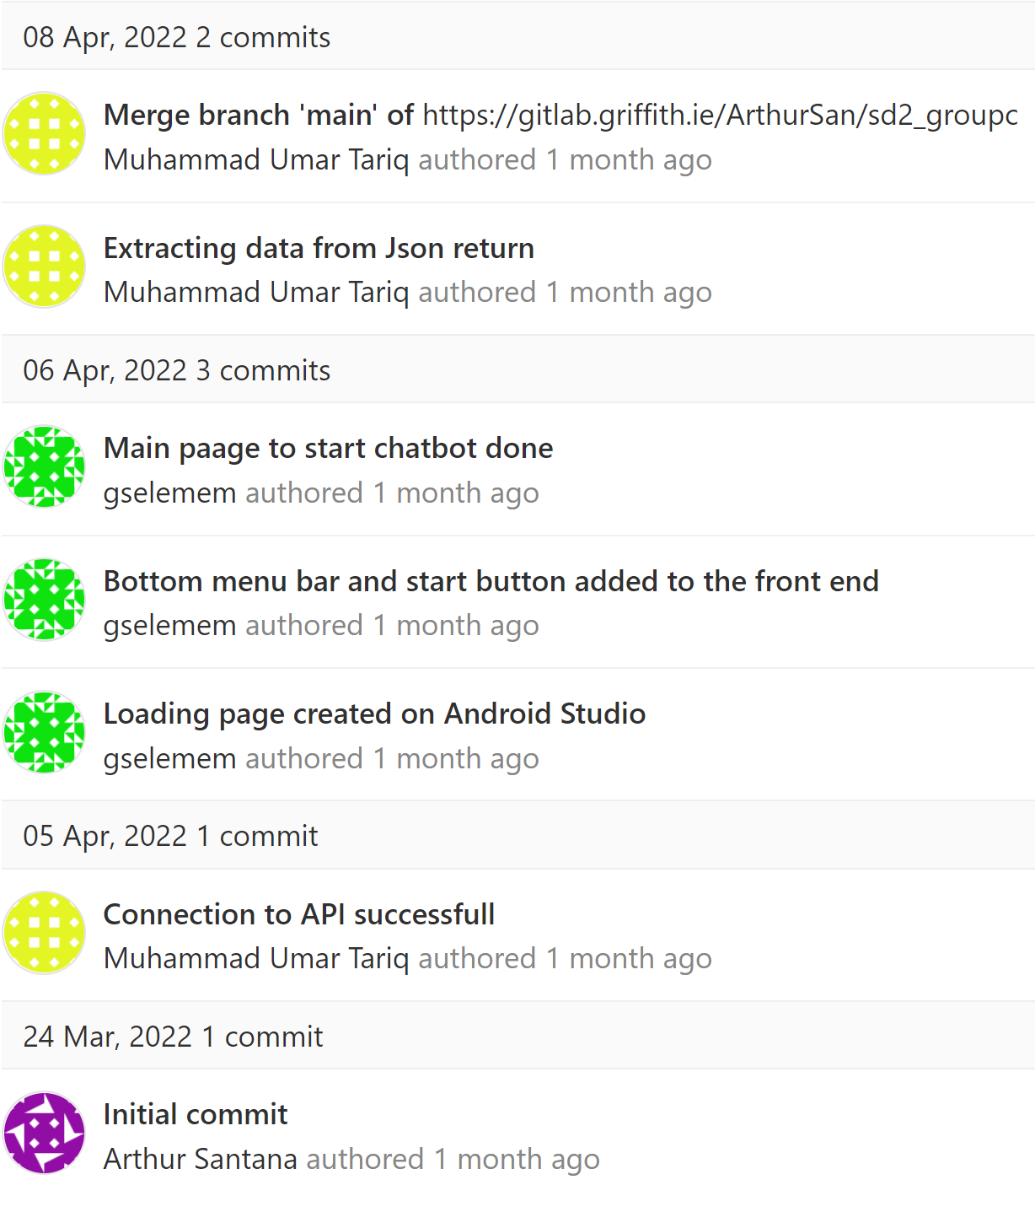

# **Conclusion**

Looking at the whole picture, we have achieved most of what was asked in the initial briefing. We have created an app that takes in the location and number of days from the user and returns the weather conditions of those days. The bot also suggests clothing based on the weather conditions using hard coded if statements.

For the future, the team plans to add voice recognition using Speech to Text library and buying links for the clothes suggested. Also, the team plans on making the chatbot more conversational and with more functionality.